Task 2

Task 1 – Payment Processing System
import java.util.Scanner;
interface Payment {
void pay(double amount);
}
class CreditCardPayment implements Payment {
public void pay(double amount) {
System.out.println("Processing payment using Credit Card");
System.out.println("Amount paid: ₹" + amount);
System.out.println("Payment Successful");
}
}
class UPIPayment implements Payment {
public void pay(double amount) {
System.out.println("Processing payment using UPI");
System.out.println("Amount paid: ₹" + amount);
System.out.println("Payment Successful");
}
}
class NetBankingPayment implements Payment {
public void pay(double amount) {
System.out.println("Processing payment using Net Banking");
System.out.println("Amount paid: ₹" + amount);
System.out.println("Payment Successful");
}
}
public class Main {
public static void main(String[] args) {
Scanner sc = new Scanner(System.in);
System.out.println("Enter payment type (1-CreditCard, 2-UPI, 3-NetBanking):");
int type = sc.nextInt();
System.out.println("Enter amount:");
double amount = sc.nextDouble();
Payment payment;
if (type == 1) {
payment = new CreditCardPayment();
}
else if (type == 2) {
payment = new UPIPayment();
}
else if (type == 3) {
payment = new NetBankingPayment();
}
else {
System.out.println("Invalid Payment Type");
return;
}
payment.pay(amount);
}
}
Output:
Enter payment type (1-CreditCard, 2-UPI, 3-NetBanking):
2
Enter amount:
23,000
Processing payment using UPI
Amount paid: ?23000.0
Payment Successful
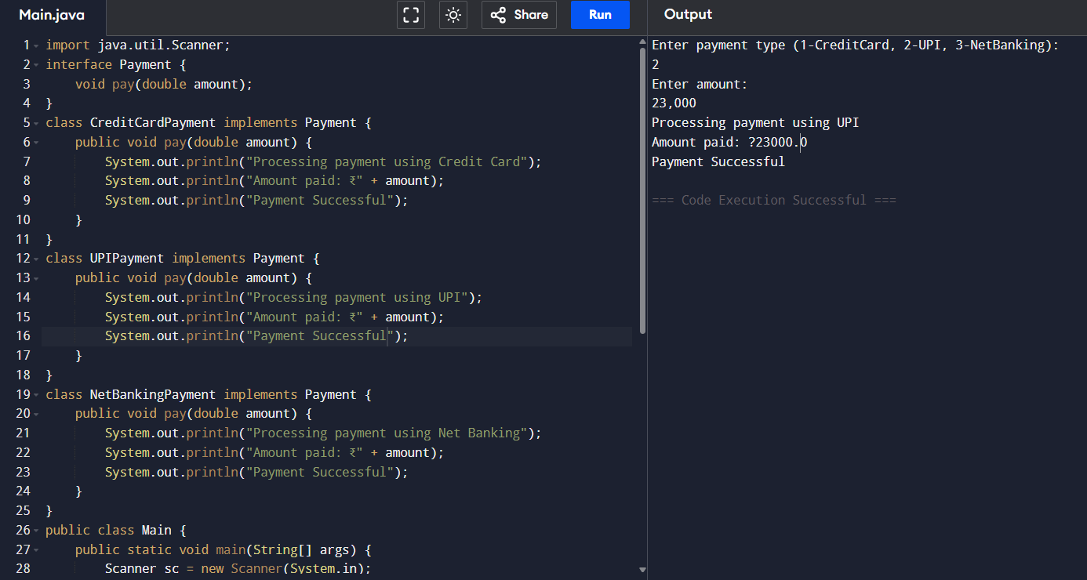

Task 2 – Shape Area Calculator Problem
import java.util.Scanner;

interface Shape {
double calculateArea();
}

class Circle implements Shape {
double radius;

Circle(double radius) {
this.radius = radius;
}

public double calculateArea() {
return 3.1416 * radius * radius;
}
}

class Rectangle implements Shape {
double length, width;

Rectangle(double length, double width) {
this.length = length;
this.width = width;
}

public double calculateArea() {
return length * width;
}
}

class Triangle implements Shape {
double base, height;

Triangle(double base, double height) {
this.base = base;
this.height = height;
}

public double calculateArea() {
return 0.5 * base * height;
}
}

public class Main {

public static void main(String[] args) {

Scanner sc = new Scanner(System.in);

System.out.println("Enter shape type (1-Circle,2-Rectangle,3-Triangle):");
int type = sc.nextInt();

Shape shape = null;

if (type == 1) {
System.out.println("Enter radius:");
double r = sc.nextDouble();
shape = new Circle(r);
System.out.println("Shape Selected: Circle");
}

else if (type == 2) {
System.out.println("Enter length:");
double l = sc.nextDouble();
System.out.println("Enter width:");
double w = sc.nextDouble();
shape = new Rectangle(l, w);
System.out.println("Shape Selected: Rectangle");
}

else if (type == 3) {
System.out.println("Enter base:");
double b = sc.nextDouble();
System.out.println("Enter height:");
double h = sc.nextDouble();
shape = new Triangle(b, h);
System.out.println("Shape Selected: Triangle");
}

else {
System.out.println("Invalid Shape");
return;
}

double area = shape.calculateArea();
System.out.printf("Area = %.2f", area);
}
}
Output:
Enter shape type (1-Circle,2-Rectangle,3-Triangle):
2
Enter length:
34
Enter width:
21
Shape Selected: Rectangle
Area = 714.00
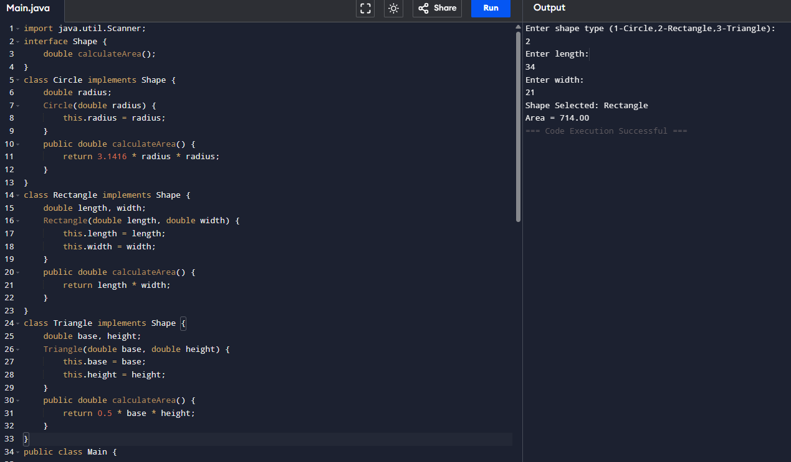

Task 3 – Employee Bonus System Problem
import java.util.Scanner;
interface BonusCalculator {
double calculateBonus(double salary);
}
class FestivalBonus implements BonusCalculator {
public double calculateBonus(double salary) {
return salary * 0.20;
}
}
public class Main {
public static void main(String[] args) {
Scanner sc = new Scanner(System.in);
System.out.println("Enter employee salary:");
double salary = sc.nextDouble();
BonusCalculator bonusCalculator = new FestivalBonus();
double bonus = bonusCalculator.calculateBonus(salary);
double totalSalary = salary + bonus;
System.out.println("Salary: " + salary);
System.out.println("Festival Bonus: " + bonus);
System.out.println("Total Salary after Bonus: " + totalSalary);

sc.close();
}
}
Output:
Enter employee salary:
23999
Salary: 23999.0
Festival Bonus: 4799.8
Total Salary after Bonus: 28798.8
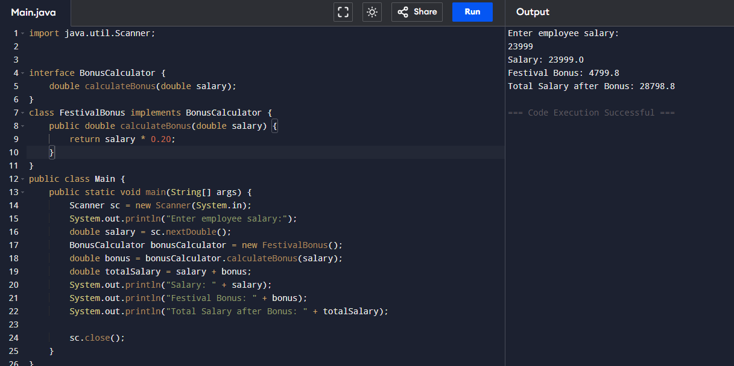

Task 4 – Temperature Converter Problem
import java.util.Scanner;
interface Converter {
double convert(double value);
}
class CelsiusToFahrenheit implements Converter {

public double convert(double celsius) {
return (celsius * 9 / 5) + 32;
}
}
class FahrenheitToCelsius implements Converter {

public double convert(double fahrenheit) {
return (fahrenheit - 32) * 5 / 9;
}
}
public class Main {
public static void main(String[] args) {
Scanner sc = new Scanner(System.in);
System.out.println("Choose conversion");
System.out.println("1. Celsius to Fahrenheit");
System.out.println("2. Fahrenheit to Celsius");
int choice = sc.nextInt();
System.out.println("Enter temperature:");
double temp = sc.nextDouble();
Converter converter;
if (choice == 1) {
converter = new CelsiusToFahrenheit();
double result = converter.convert(temp);
System.out.println("Converted Temperature = " + result + " Fahrenheit");
}
else if (choice == 2) {
converter = new FahrenheitToCelsius();
double result = converter.convert(temp);
System.out.println("Converted Temperature = " + result + " Celsius");
}
else {
System.out.println("Invalid Choice");
}
sc.close();
}
}
Output:
Choose conversion
1. Celsius to Fahrenheit
2. Fahrenheit to Celsius
1
Enter temperature:
34
Converted Temperature = 93.2 Fahrenheit
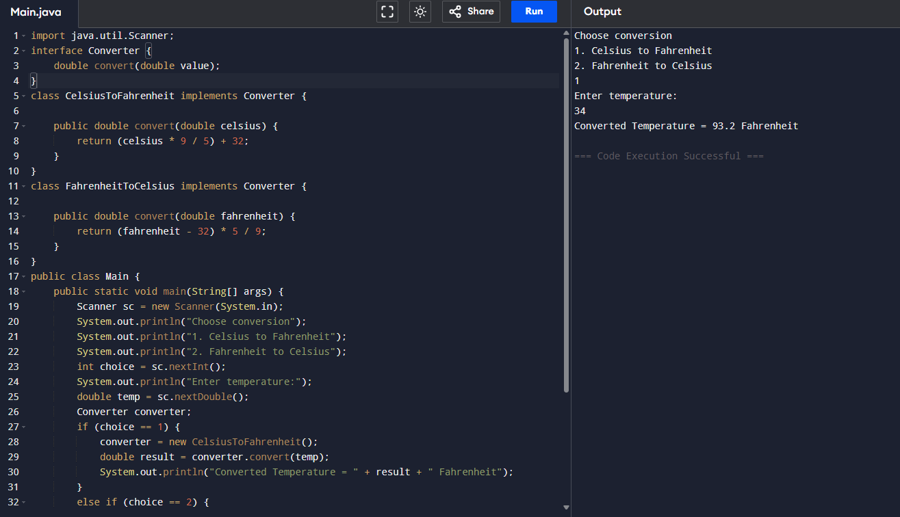
Task 5 – Sorting System
import java.util.Scanner;
interface Sorter {
void sort(int[] arr);
}
class BubbleSort implements Sorter {
public void sort(int[] arr) {
int n = arr.length;
for (int i = 0; i < n - 1; i++) {
for (int j = 0; j < n - i - 1; j++) {
if (arr[j] > arr[j + 1]) {
int temp = arr[j];
arr[j] = arr[j + 1];
arr[j + 1] = temp;

}
}
}
}
}
public class Main {
public static void main(String[] args) {
Scanner sc = new Scanner(System.in);
System.out.println("Enter number of elements:");
int n = sc.nextInt();
int[] arr = new int[n];
System.out.println("Enter elements:");
for (int i = 0; i < n; i++) {
arr[i] = sc.nextInt();
}
Sorter sorter = new BubbleSort();
sorter.sort(arr);
System.out.println("Sorted Array:");
for (int i = 0; i < n; i++) {
System.out.print(arr[i] + " ");
}
sc.close();
}
}
Output:
Enter number of elements:

4
Enter elements:
23 45 97 34
Sorted Array:
23 34 45 97
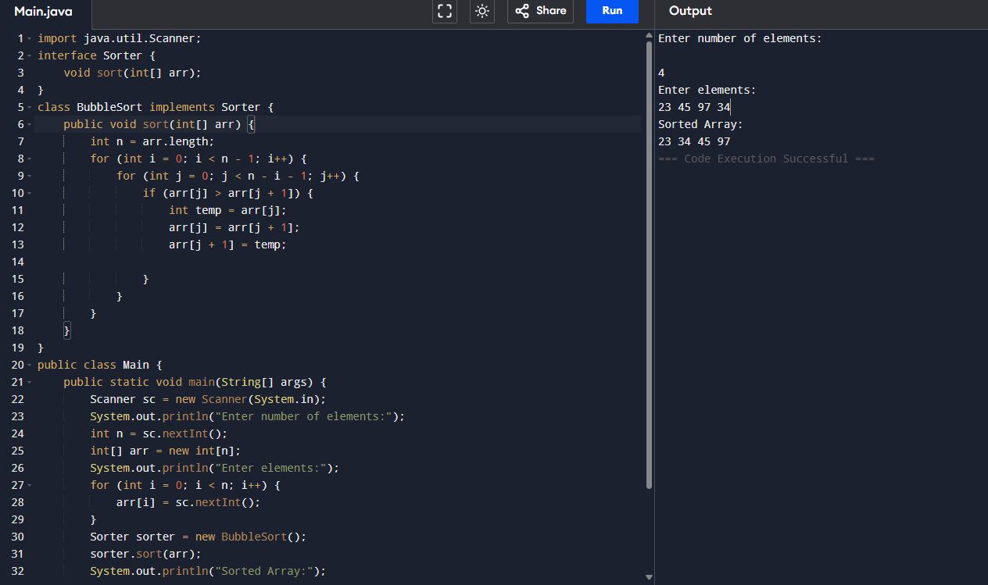

Task 6 – Notification System Problem
import java.util.Scanner;
interface Notification {
void sendMessage(String message);
}
class EmailNotification implements Notification {
public void sendMessage(String message) {
System.out.println("Sending Email Notification");
System.out.println("Message: " + message);
System.out.println("Message Sent Successfully");
}
}
class SMSNotification implements Notification {
public void sendMessage(String message) {
System.out.println("Sending SMS Notification");
System.out.println("Message: " + message);
System.out.println("Message Sent Successfully");
}
}
class PushNotification implements Notification {
public void sendMessage(String message) {
System.out.println("Sending Push Notification");
System.out.println("Message: " + message);
System.out.println("Message Sent Successfully");
}
}
public class Main {
public static void main(String[] args) {
Scanner sc = new Scanner(System.in);
System.out.println("Choose Notification Type");
System.out.println("1 Email");
System.out.println("2 SMS");
System.out.println("3 Push");
int choice = sc.nextInt();
sc.nextLine(); // consume newline
System.out.println("Enter message:");
String message = sc.nextLine();
Notification notification;
if (choice == 1) {
notification = new EmailNotification();
}
else if (choice == 2) {
notification = new SMSNotification();
}
else if (choice == 3) {
notification = new PushNotification();
}
else {
System.out.println("Invalid Notification Type");
return;
}

notification.sendMessage(message);

sc.close();
}
}
Output:
Choose Notification Type
1 Email
2 SMS
3 Push
1
Enter message:
hii Nandhy!
Sending Email Notification
Message: hii Nandhy!
Message Sent Successfully
